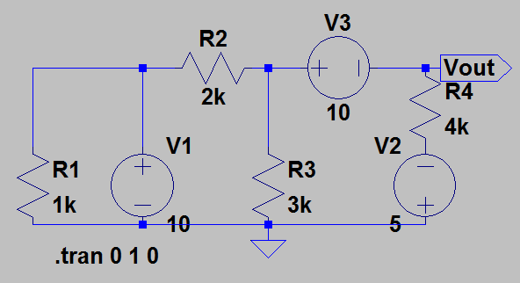HW#3b

Problem 2.40

Vout=-4.23V

Power added to circuit:

P1=121.15mW

P2=0.96mW

P3=-1.92mW (battery is being charged).

