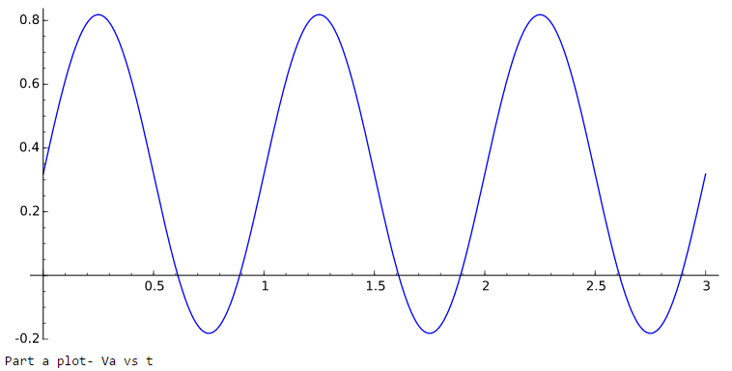Chapter 4 solutions companion:

4.6)

1. The DC and fundamental is, in sage,

t=var('t')

n=var('n')

omega0=2\*pi

Va(t)=1/pi+sin(omega0\*t)/2

plot(Va(t),t, 0, 3)

1. The DC and terms through =20 is, again in sage,

Vb(t)=1/pi+sin(omega0\*t)/2-2/pi\*sum(cos(2\*n\*omega0\*t)/(n\*(n+2)), n, 1, 5)

plot(Vb(t),t,0,3)

print('Part b plot- Vb vs t')

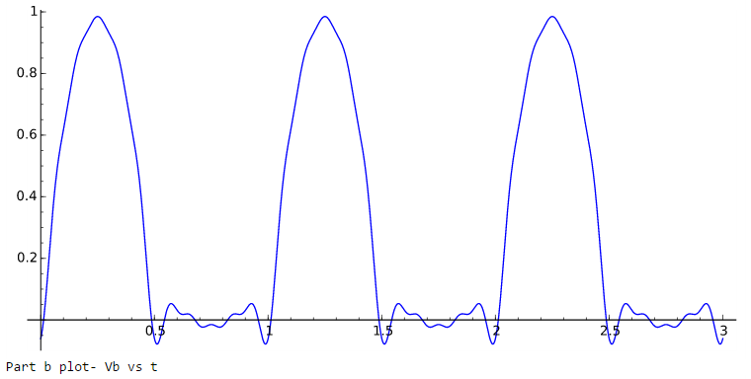

1. And finally with lots of terms (first 100 harmonics)

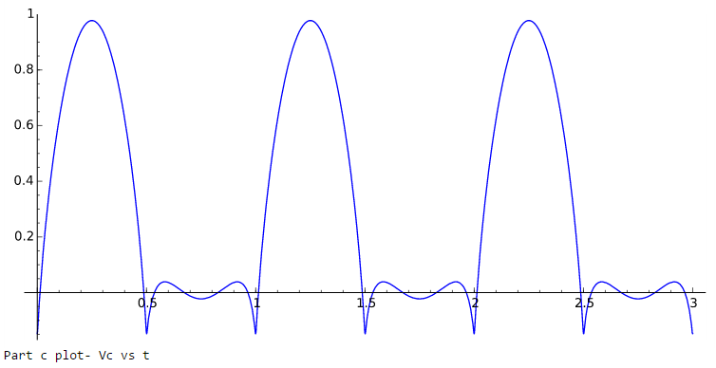

4.7)

1. The input including the first 100 harmonics and the output. Notice that the sharp edges of the wave form have been filtered away.

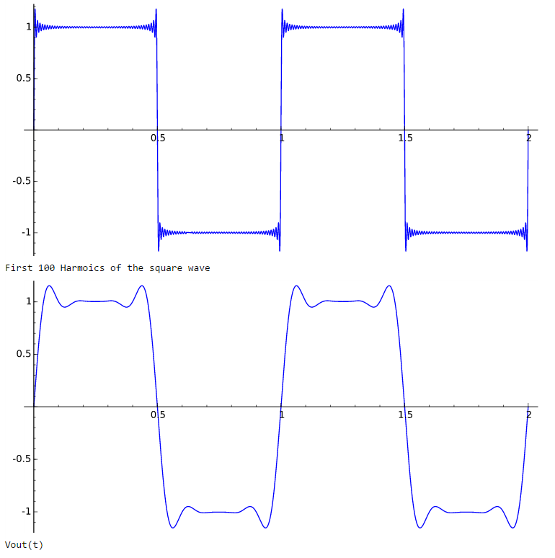

4.15The first terms are more important than the last 17 for capturing the rough form, and the high terms capture the sharpness of the switch from 1 to -1.

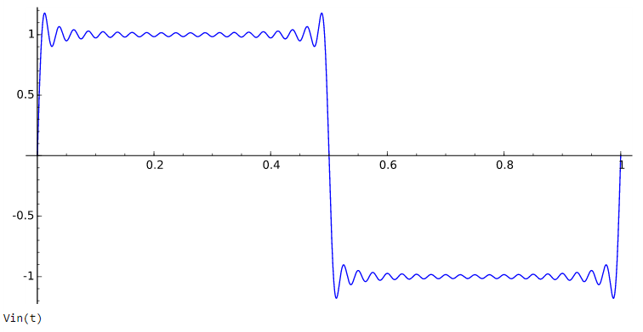

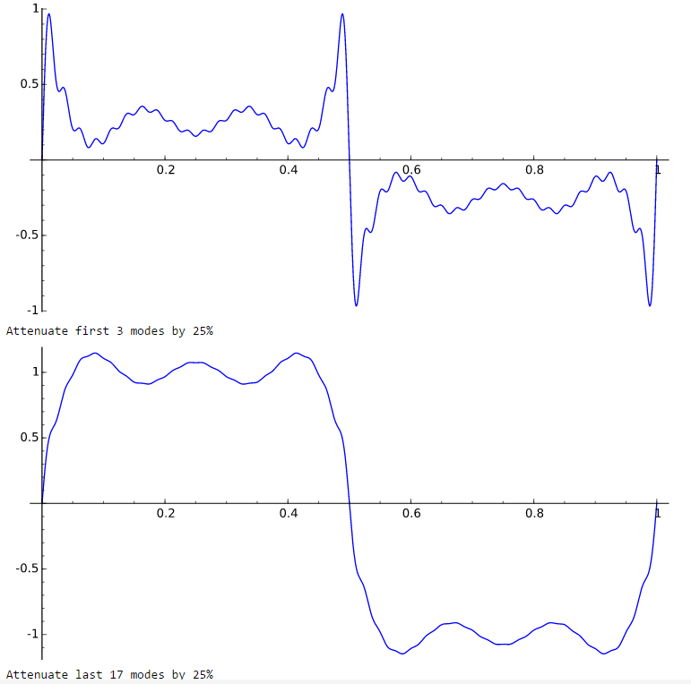

4.21 The derivative $\frac{dx_{out}}{dt}$ vs $x_{out}$ is substantially linear as you would expect for a first order system. The fit to the data is dxoutdt=-0.35 xout+1.8. Based on this the time constant $τ=\frac{1}{0.35}=2.86s.$ The static sensitivity depends on the

