Writing Assignment:
The Value of Life—Developing Multiple Perspectives

Joyce Hansen

This assignment is part of a genre study on poetry for a 10th grade class.

The class has just finished reading the short story “Flowers for Algernon” by Daniel Keyes. In that story, a laboratory mouse is used for experimental surgery to increase intelligence as a test subject. The story is told through the eyes of a man named Charlie, who has undergone the same surgery. The class has spent time debating the positive and negative sides of animal testing and exploring advances in medicine that were only possible through the use of laboratory animals as test subjects. We have been writing blog responses to the text every day as a way to warm up, before the discussion begins. The students are getting better at working out their thoughts on their blogs before sharing in class.

The class has also spent a significant amount of time doing writing workshops in small groups. They are fully aware of the behavior required during writing workshops, the expectations for helpful comments, and usefulness of having a small audience as a sounding board. They have been working very hard on accepting criticism graciously and learning to offer criticism in a constructive way.

After this writing assignment is complete, the students will have produced a 350-500 word narrative. When the students have finished this project, they will then create a poem. They will work as partners, exchanging the narrative pieces they have produced. Each student will turn his partner’s narrative into a poem, using a new perspective. This will allow the students an opportunity to change perspectives once again. It will reinforce how important perspectives are, and emphasize how different people think differently. In effect, this project will promote diversity and tolerance.

This writing assignment is part of a genre study on poetry. The poetry unit will incorporate many different kinds of poetry, and these poems will give the class an opportunity to talk about the value of human life while modeling tolerance for diverse perspectives.

It is important to consider poetry in connection with other kinds of written expression, otherwise it might seem daunting to students. Blending these poems with narrative, as a medium of working out ideas in standard sentence structure, may make the genre of poetry slightly more accessible. Reading poems in class gives students solid models to reference and to base their own poetry upon. A student cannot write poetry without having read poetry first. This writing assignment combines narrative writing with the production of poetry in order to give students a sense of confidence within the project. They have already spent time learning narrative, so they feel self-assured when tackling this project even though the poetry part is new to them. Offering students the opportunity to feel confident in a classroom promotes engagement.

When the students walk in, I instruct them to sit down at a computer and write a blog entry. They are to free-write on their blogs about their thoughts in general on animals and responsibility. I offer them the following prompts:

- As a student, I have had the opportunity to dissect an animal in school. I felt…

- As a daughter/son, I have had the responsibility of taking care of a family pet. I felt…

- As a citizen, I have had the opportunity to visit the local zoo/animal shelter/farm. I felt…

When the five-to-seven minute blog session is over, I ask the students to arrange their chairs in a large circle. I place a large box in the middle of the circle, on the top of a desk. On one side of the box, there is a picture of a rat. On another side of the box, there is a picture of a rat, dead, in a mousetrap. On another side of the box, there is a drawing of a man ailing from the Bubonic Plague, along with the words “plague transmitted by the rat flea.” On the last side of the box, there is a picture of a person holding a rat. Depending upon where a student is sitting, she is only able to see one or two sides of the box. I instruct the students to do a free write on what they see and how they feel about the rat on the box in their journals. This free write goes on for ten minutes.

plague transmitted by the rat flea

Once the students have finished, I ask them to volunteer their thoughts on the rat they viewed. Was it a friendly rat? Was it clean? I write down the students’ thoughts on the dry-erase board. There should be a variety of responses concerning the desirability of the rat, based upon the photo that was viewed. The ones that are positive should be grouped together, and the ones that are negative should be grouped together. Once the class has shared their responses, we discuss why each response was different. We turn the box around and show how sitting in a different seat yielded a different perspective.

Next, I pass the copies of Lucille Clifton’s “[at last we killed the roaches]” and Lucien Stryk’s “EXTERMINATOR” out to the students. Then, I read “[at last we killed the roaches]” out loud. The students follow along. On line 7, I pause at “we were glad, such cleanliness was grace” and think about it. I talk about how roaches are very difficult to live with they are not clean. We would not want them in our food or in our beds. I pause again after the last line “it was murder murder/all over the place” (11). I think out loud about how the speaker in Clifton’s poem feels bad about killing the roaches, which is in direct contrast with the previous line we talked about. Then, I ask the students to take a moment and read the poem to themselves. Then I ask them to write some notes about how the speaker’s mom might have felt.

Then, I read “EXTERMINATOR” by Lucien Stryk out loud. I read it a second time, and I stop this time when I read the second line, “the/exterminator cringes.” I wonder why he would be cringing. I ask the class if they have any ideas. Does he not enjoy his job? Is he too tired to go? Does he have an aversion to the sound of his phone? What could it be? I pause on line 5, “stalling them for hours.” Again, I wonder why he stalls. After reading stanza 5, I stop altogether. Why would an exterminator pick a job where he has to kill animals that he loves? I ask this question to the class. Did he begin doing the job before he cared about animals? Why does he continue to do it? The last line of the poem, “he knows who will survive” is telling. I ask the students to think about who the exterminator thinks will survive in the long run. I ask them to write about that for a few minutes.

Then, I ask the students to pick one of the poems. They are to read the poem and adopt a different perspective than that of the speaker of the poem. Students are already familiar with narrative writing, as we have spent a great deal of time reading narratives in an earlier unit. They feel comfortable writing narrative pieces, and have done so on several occasions. For this assignment, they may retell the poem from the perspective of the roaches or the mother in “[at last we killed the roaches.]” Or, they may retell “EXTERMINATOR” from the perspective of the exterminator’s wife, or the family that has called, or the animals to be exterminated, or the exterminator’s boss, or any other perspectives that they can think of. Then, they are to write a short narrative piece, using this different perspective, in order to show us the other side of the issue.

Your Task: After reading these poems, choose one that you wish to work on for further meaning. Adopt a different perspective than the narrator. Fill in a free-write diagram as a way to organize your thoughts.
I am writing from the perspective of

The poem I chose was:

By

I think the narrator is

Because

I think the narrator should

Because

The reason why the narrator worries me is

Because

I look like

I feel

Purpose and Audience: The purpose of your narrative is to push yourself to see something from a different perspective. You want to take information that is given to you from the narrator of a poem and look at it from a different point of view. Your audience will be the readers of our online blog site, as your finished project will be published electronically.

Format: Please write a 350 to 500 word narrative piece that you are able to upload to our class website. It will need to be created in a word processing program. Please choose a 12-point font that is easy to read.

Checklist:
- Cite the poem you have chosen at the end of your work. After your last paragraph, include a sentence with the title of the poem and the author and the reason you chose to rethink this perspective.

- Run a spell check on your piece before uploading it.

- Do a word count to make sure that you have met the criteria.

- Refer to the poem in your narrative, specifically addressing lines or words

- Keep your narrative organized: with an introduction, body, and conclusion

- Incorporate vocabulary from our class lists, wherever possible

- Workshop your narrative, using our workshop rules and questions, and revise your work based on your peer advice

- Offer solid advice on the improvements of your classmates’ narratives, including mentioning areas that were confusing, areas that didn’t seem consistent, and areas that needed to have more details

- Create a list of the advice you were offered in workshop and include that with the next draft

Due Date: You will work on this writing in class on Tuesday and print out a rough draft.

This rough draft will be workshopped in your small groups on Wednesday. You will have all of Wednesday to work on these drafts, so make sure you get to everyone in the group.

On Friday, you will turn in your second draft to me with the comments from your workshop. On Monday I will give you back your narrative, with my own suggestions. Please revise.

The final draft is due next Wednesday, by the end of class.

After the first draft is produced, the students will workshop in small groups. The workshopping questions are well known to the class as they have done this on several other occasions. They will focus on areas that seem confusing, areas that are inconsistent (that seem to stray from the original perspective or point) and areas that need more details in order to create a solid characterization of the chosen perspective. Once the workshopping is finished, the students will use this advice during their next revision of their drafts.

After the workshop class, I will do a mini-lesson on voice and word choice. This mini-lesson will include several examples from literature of “voices” that display different types of characters. I will use passages from A True and Faithful Narrative by Katherine Sturtevant, in which the protagonist is a young girl who lives in 1681. I will include a passage from M.T. Anderson’s Feed, in which the protagonist is a young boy in the future. And I will present a passage from Tyrell by Coe Booth, in which the protagonist is a young man who lives in a city, present day. Differences in vocabulary, terminology, syntax, and formality will each be discussed and examined. Then, the students will revise their drafts based upon their workshop suggestions and the mini-lesson on voice.

The class will turn in their second drafts for teacher commenting and then revise based upon that. After I have read the drafts and isolated common mistakes I will hand back these second drafts. I will do a mini-lesson on editing that addresses problems that many of the students seemed to have. This lesson might be on syntax or style, or anything else that seems to be problematic. This mini-lesson should cater specifically to this class, and these students, and this piece of work. The students will use the teacher comments and the mini-lesson on editing to revise their narratives one last time.

This last revision will be the final draft.

Eventually each student will write a poem of his own employing what we have learned here about perspectives. The students will work in partnerships. Each student will then turn his partner’s narrative into a new poem which is written from a new perspective. In this way, students will be expanding upon the notion that perspective can make all the difference in the world when retelling events. This will solidify the learning that we have done, while working with both poetry and narrative. It will also allow students to remix the original poem by creating a new narrative perspective, and then creating a new poem based upon that narrative. The original poem will be twice removed from the end product, but will remain present in the background. In this way, we will be encouraging our students to become better remixers of information, going two steps away from inspiration in their efforts to recreate. This is excellent preparation for the kinds of new literacies that they will face in a world where remix is used for representing information in fresh and individualized ways.

NYS English Language Arts Standards

Standard 1: Students will read, write, listen, and speak for information and understanding.
Students will blog about their own feelings on the issue, to better understand their thoughts through writing.

Standard 2: Students will read, write, listen, and speak for literary response and expression.
Students will read and hear the poems, they will respond to the demonstration in class in their journals, and they will share their thoughts out loud.

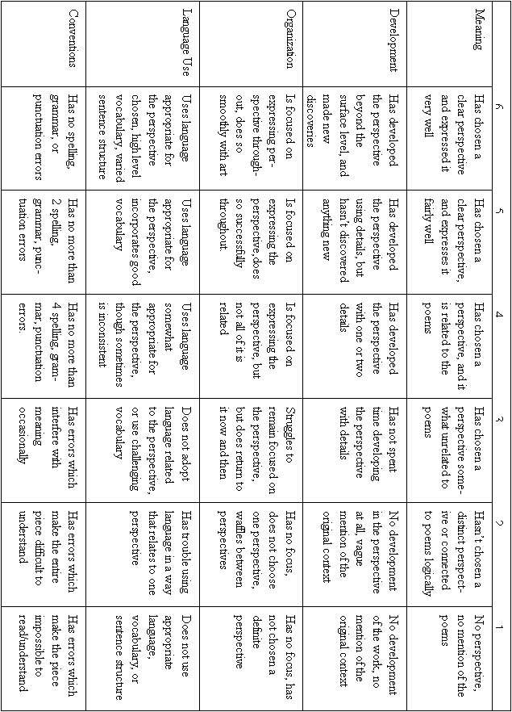
Two Representative Poems

[at last we killed the roaches]

at last we killed the roaches.
mama and me. she sprayed,
i swept the ceiling and they fell
dying onto our shoulders, in our hair
covering us with red. the tribe was broken,
the cooking pots were ours again
and we were glad, such cleanliness was grace
when i was twelve. only for a few nights,
and then not much, my dreams were blood
my hands were blades and it was murder murder
all over the place.

—Lucille Clifton, page 77

EXTERMINATOR

Phone vibrates all winter. The
exterminator cringes—
yet another squeal, demanding

he come fast. He plays at cat
and mouse, stalling them for hours,
days. Then pocketing thick

gloves, flashlight, steelwool,
poison, he enters musty corners,
sets dry traps, pours tempting

pellets into little paper boats,
launches them here and there.
As he stuffs holes, he contemplates

the toughness of a world which
outlaws creatures he has learned
to love: starved them from frozen

corn-stripped fields, small wonder
they outsmart those who grudge them
a few crumbs, a little warmth. The

exterminator does his job, takes his
money, leaves. In the long run of
things, he knows who will survive.

—Lucien Stryk, page 598

Sample Writing Assignment on Multiple Perspectives
Joyce Hansen
ENG 505

Through Mama’s Eyes

Our apartment has been infested with roaches for weeks now. I called the landlord at least fifteen times complaining about the problem. It doesn’t matter how many times I go buy that spray poison I can’t seem to get rid of them. I think they live in the walls.
Last week, I asked my daughter to help me. I was just fed up, and I couldn’t stand to see the dishes covered in those dirty roaches any longer. It killed me to ask her; I don’t want to show her how much of a struggle it is to keep an apartment clean. The worst thing in the world is the feeling that your kids see you as a failure, unable to meet basic needs like sanitary living conditions. When she grows up, I want her to remember me with an apron on, baking cookies—not with dead roaches falling in my hair.
I know it’s an invasion of privacy, but I read her diary. You probably won’t understand why. My girl doesn’t talk to me she doesn’t tell me about the boys she hangs around with. I worry that she’s out on the playground, mixing in with the wrong crowd. Don’t think I’ve forgotten what it’s like to have a bunch of friends: the ones who push you on to have intimate relations and do things you shouldn’t. It wasn’t that long ago that I was in her position. She came out of me when I was only sixteen, so I know what kind of trouble kids can get into.
My daughter wrote a poem she called “[at last we killed the roaches]” in her diary, after the episode in the kitchen last week. She wrote that she had nightmares about it, that she felt like it was murder. I know she was glad to be rid of the roaches, just like me, but it made me so sad to read that she was traumatized by the killing. It’s awful to think about asking your child to kill. I know it’s only roaches, but it’s the principle. Somebody told me that serial killers start small, with little animals. Who knows, maybe their moms asked them to kill roaches when they were small children. It just makes me sick to think I asked her to help me.
Still, I keep thinking that it’s only roaches. I mean, is it such a big deal? These disgusting little creatures shouldn’t be in our apartment. They’re dirty. They track their germs all over our home, all over our dishes and our food. When I’m in bed, trying to fall asleep, it bothers me to think that they’re all coming out in the darkness. I sometimes turn on my bedroom light and see that there’s a roach on my blanket. Or, I see one on my pillow. Or, I imagine there’s one on my toothbrush or on the stick of butter in the cabinet. Or, I imagine there’s one crawling on my daughter’s face as she sleeps, and it doesn’t care that she’s just a little girl. It doesn’t know that its feet are covered in germs. When I think about these things, I am glad I gave my daughter that poison. I’m glad I gave her the toughness to fight back. Nightmares go away; it’s the roaches we can’t live with in the end.

